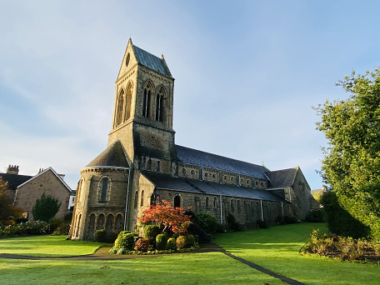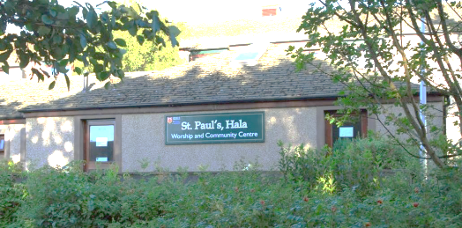**ST PAUL’S PARISH NEWS**

5th May 2022

**Sunday Worship 8th May 2022**

Fourth Sunday of Easter

08:00 BCP Holy Communion at St Paul’s, Scotforth Road

09:45 Holy Communion at St Paul’s, Scotforth Road

11:15 – Holy Communion at St Paul’s, Hala

16:00 Worship@4: Taizé Prayer Service

Thursday – 09:15 Holy Communion at St Paul’s, Scotforth Road

**Morning Prayer** by telephone conference each Wednesday – at 09.00. Please contact Margaret Ives if you would like to join the telephone conference.



***Worshipping God,***

***Growing in Faith,***

***Serving the Community.***

**FOR OUR PRAYERS**

**Our mission Partners:** For Stephen and Marit Impey's work with Wycliffe Bible Translators International.

**From our Parish prayer diary:**  Lentworth Drive, Yealand Drive

**From our Church prayer diary:**  Christian Aid

**Those who have asked for prayers for healing:** Mary Wilson, Eunice Parkinson, Marion Corkill, Maureen Thorpe, Rev Rebecca, Mollie Glover, Reg Wollington, Mary Smith, Arton Medd, Peter, Dorothy Camm, Denis & Barbara Beetham

**All who mourn:** Pirkko Leong, Robert Smith, Emma Jane Lamb

**Collect for 8th May 2022:**

Risen Christ,

faithful shepherd of your Father's sheep:

teach us to hear your voice

and to follow your command,

that all your people may be gathered into

one flock,

to the glory of God the Father.

Amen

**Readings for 8th May 2022:**

## Acts 9.36-end

36 Now in Joppa there was a disciple whose name was Tabitha, which in Greek is Dorcas. She was devoted to good works and acts of charity. 37At that time she became ill and died. When they had washed her, they laid her in a room upstairs. 38Since Lydda was near Joppa, the disciples, who heard that Peter was there, sent two men to him with the request, ‘Please come to us without delay.’ 39So Peter got up and went with them; and when he arrived, they took him to the room upstairs. All the widows stood beside him, weeping and showing tunics and other clothing that Dorcas had made while she was with them. 40Peter put all of them outside, and then he knelt down and prayed. He turned to the body and said, ‘Tabitha, get up.’ Then she opened her eyes, and seeing Peter, she sat up. 41He gave her his hand and helped her up. Then calling the saints and widows, he showed her to be alive. 42This became known throughout Joppa, and many believed in the Lord. 43Meanwhile he stayed in Joppa for some time with a certain Simon, a tanner.

## John 10.22-30

22 At that time the festival of the Dedication took place in Jerusalem. It was winter, 23and Jesus was walking in the temple, in the portico of Solomon. 24So the Jews gathered around him and said to him, ‘How long will you keep us in suspense? If you are the Messiah,[*](javascript:void(0);) tell us plainly.’ 25Jesus answered, ‘I have told you, and you do not believe. The works that I do in my Father’s name testify to me; 26but you do not believe, because you do not belong to my sheep. 27My sheep hear my voice. I know them, and they follow me. 28I give them eternal life, and they will never perish. No one will snatch them out of my hand. 29What my Father has given me is greater than all else, and no one can snatch it out of the Father’s hand.[*](javascript:void(0);) 30The Father and I are one.’

**Post Communion Prayer:**

Merciful Father,

you gave your Son Jesus Christ to be the good shepherd,

and in his love for us to lay down his life and rise again:

keep us always under his protection,

and give us grace to follow in his steps;

through Jesus Christ our Lord.

*Shared from the Lectionary app. Material subject to copyright. Please visit the About this App page for further information.*

**Readings for next Sunday:**

**[Baruch 3.9-15, 32-4.4 *or* Genesis 22.1-18]**

**Acts 11.1-18; Psalm 148; Revelation 21.1-6; John 13.31-35**

**The Electoral Roll:**

As I write this there are 155 people on our church’s electoral roll. I can count the number of applications received since 2019 on one hand, so I thought I should put a short note in the Parish News about the electoral roll.

The electoral roll exists to record those who are entitled to vote at the Annual Parish Meeting [APM] which selects the Parochial Church Council [PCC]. Candidates must have been on the roll for at least 6 months before the APM at which they offer themselves for election to the PCC. If you are considering standing for the PCC in 2023, and are not yet on the roll, please join the roll now.

The electoral roll is the foundation of the system of government used by the Church of England. Each parish is allocated a number of seats on its local Deanery Synod based on the number on its electoral roll. The lay members of the Deanery Synod elect the lay members of the Diocesan Synod and the General Synod. The General Synod effectively is the parliament which makes the policy decisions that determine how the Church of England operates.

If you are baptized, at least 16 years old, and regard yourself as a member of our worshipping community, joining the electoral roll is a good way to record that membership. The process is simple: just complete a form. **There is no membership fee**. There should be forms available in church, just ask a sidesperson at a service at Scotforth Road or Hala. If you have any difficulty getting a form, you can email me on [jdennyg41@gmail.com](mailto:jdennyg41@gmail.com)

***John Gedge, Electoral Roll Officer***

**Submissions for the Parish News**:

The deadline each week is Tuesday at noon but we can always add contributions to the following week’s Parish News. We look forward to receiving your contributions and supporting each other in the Body of Christ during this time. Please email the parish office, leave a message on the answer machine for a telephone submission or post/leave an article for the Parish Office in the Parish Hall letterbox.



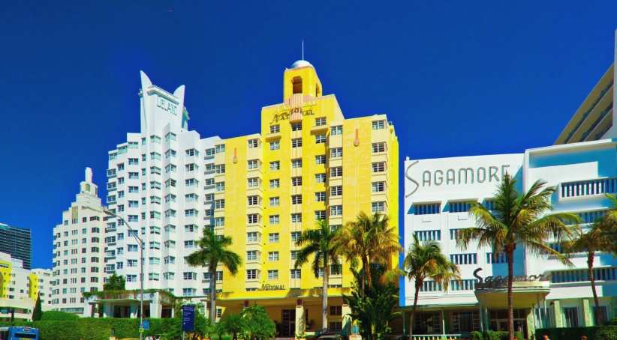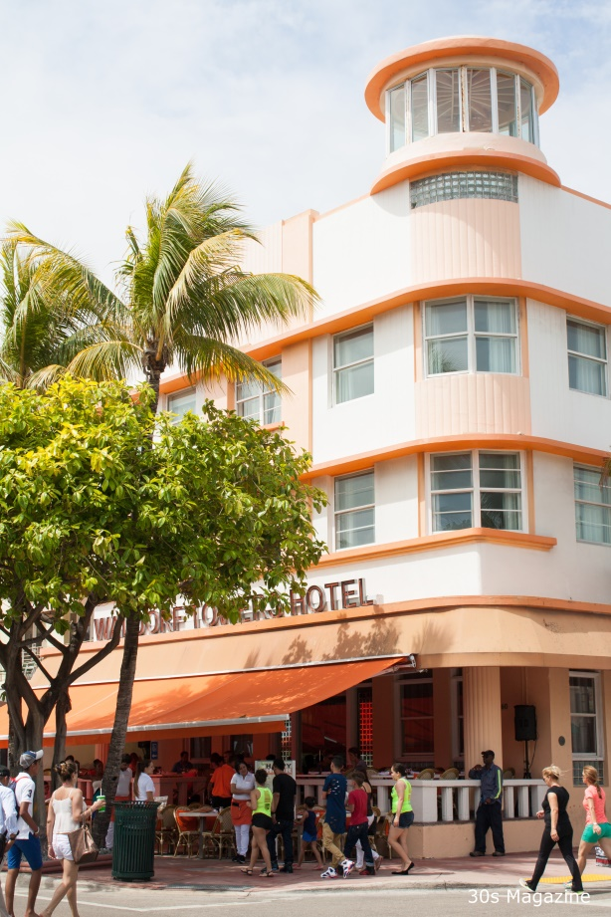

**Dates for your Diary:**   
May 6th at 7:00pm  
May 20th at 7:00pm

When there will be a series of 2 short talks in the Parish Hall  
on Miami Beach and its Art Deco.  
Miami, how it became an Hispanic capital, Hurricanes and Now.

The talks are in aid of church funds, entry will be free but donations at the end would be appreciated.

Hope to see some of you there.

**Contactless Giving in Church is now available.**

Our machine will be at the back of church so that on your way out, rather than giving a cash donation, you could consider giving by card.

**Women’s Fellowship:**

Women’s Fellowship will be meeting on Monday 9th May at 2pm in the Parish Hall. This will be a social meeting, with no speaker, so that we can all catch up with one another and discuss future plans.

Anyone who would like to join us would be most welcome, this will be an opportunity to see who we are and what we do.



**P/T VACANCY:**

**ASSISTANT PROJECT**

**MANAGER**



Do you have a concern for people in Lancaster who find themselves marginalised or facing hardship?

*So do we!*

The Olive Branch (Faith in Action) is a Christian-based charity operating a foodbank and other initiatives to support people from any faith or background in times of need.

*Could* ***you*** *join our small and dedicated staff team?*

We are currently looking to appoint a new

**ASSISTANT PROJECT MANAGER** (part-time)

now that the previous post-holder has moved on.

The post is for 20 hours a week across 3 working days.

Some flexibility in working hours to suit the right applicant.

Initial 6-month contract with possible extension.

Salary £11,526 p.a. (£23,052 pro rata)

You can find full details of the post and the application process

on our website: <https://the-olivebranch.org.uk>

or phone us on 01524 555715 for an informal conversation.

Closing date for applications: 9am Monday 16th May 2022

***The Olive Branch: so much more than a foodbank!***

**VICAR:** Rev Dr Rebecca Aechtner –

Tel: 749693; Email: [vicar@stpauls-scotforth.org](mailto:vicar@stpauls-scotforth.org)

*Rest day is Friday – if you have an urgent enquiry then please contact a Churchwarden.*

**WARDENS:**

Mrs Jayne Weatherill:

Tel: 60597; Email: [sjayneweatherill@gmail.com](mailto:sjayneweatherill@gmail.com)

**PARISH OFFICE:** The office is open Monday to Friday from 9.30am – 12 noon.

Tel: 01524 843135; Email: [office@stpauls-scotforth.org](mailto:office@stpauls-scotforth.org)

**BAPTISMS AND WEDDINGS:** Booking enquiries - please contact the parish office or

Email: [lifeevents@stpauls-scotforth.org](mailto:lifeevents@stpauls-scotforth.org)

**CHURCH WEBSITE & HOW TO HIRE OUR ROOMS:**

<https://stpauls-scotforth.org> then visit the Hiring our Spaces area at the top of the page.

**FACEBOOK:** regular updates about life at St Paul’s can be found: @scotforthstpaulschurch

**INSTAGRAM:** @scotforthstpauls

**PASTORAL CARE TEAM:** Our Clergy and Pastoral Care Team are here to listen and to pray. You can contact them by either emailing [pastoral@stpauls-scotforth.org](mailto:pastoral@stpauls-scotforth.org) or telephoning Irene on 64701.